**Q1 : What are the different margins options and do we adjust the margins of the excel worksheet?**

Ans : To use predefined margins, click Normal, Wide, or Narrow. Tip: If you previously used a custom margin setting, that setting is available as the Last Custom Setting option. To specify custom page margins, click Custom Margins and then—in the Top, Bottom, Left, and Right boxes—enter the margin sizes that you want.

**Q2 : Set a background for your table created.**

Ans : Click the worksheet that you want to display with a sheet background. Make sure that only one worksheet is selected. On the Page Layout tab, in the Page Setup group, click Background. Select the picture that you want to use for the sheet background, and then click Insert.

**Q3 : What is freeze panes and why do we use freeze panes? Give examples.**

Ans : To keep an area of a worksheet visible while you scroll to another area of the worksheet, go to the View tab, where you can Freeze Panes to lock specific rows and columns in place, or you can Split panes to create separate windows of the same worksheet.

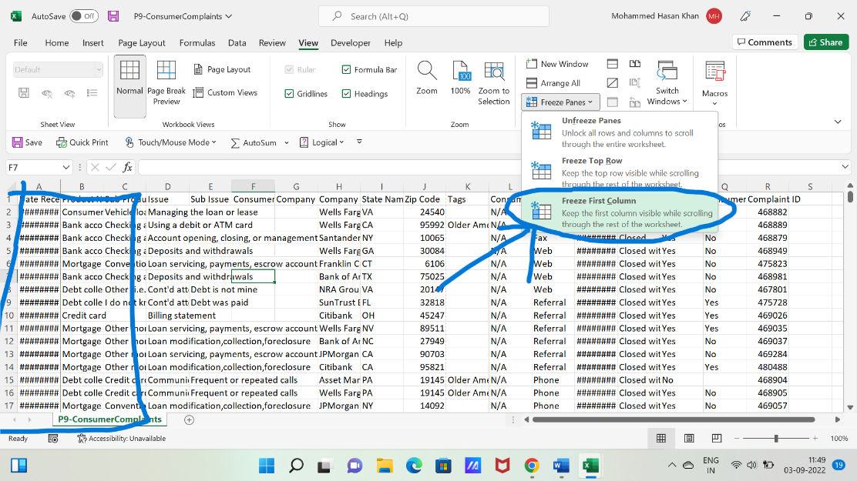

**Q4 : What are the different features available within the Freeze Panes command?**

Ans : there are three type option show freeze rows, freeze columns and unfreeze panes.

**Q5 : Explain what the different sheet options present in excel are and what they do?**

Ans : You can choose to view any workbook in Normal view, Page Layout view, or Page Break view. These views can be useful for various tasks, mainly if you're planning to print the spreadsheet.